**Introduction to Background properties**

**Que1: Create a HTML page which has a container div. This div should take height and width of the page.Add a fixed background image to this div which should cover the whole page and should not be repeated.**

**Code:**

<!doctype html>

<html lang="en">

<head>

<meta charset="UTF-8">

<meta name="viewport"

content="width=device-width, user-scalable=no, initial-scale=1.0, maximum-scale=1.0, minimum-scale=1.0">

<meta http-equiv="X-UA-Compatible" content="ie=edge">

<title>Document</title>

<style>

*, body{

width: 100%;

height: 100%;

margin: 0;

box-sizing: border-box;

}

.container{

width: 100%;

height: 100%;

background-image: url("assets/bg-image.png");

background-size: cover;

background-repeat: no-repeat;

background-attachment: fixed;

}

</style>

</head>

<body>

<div class="container">

</div>

</body>

</html>

**Output:**

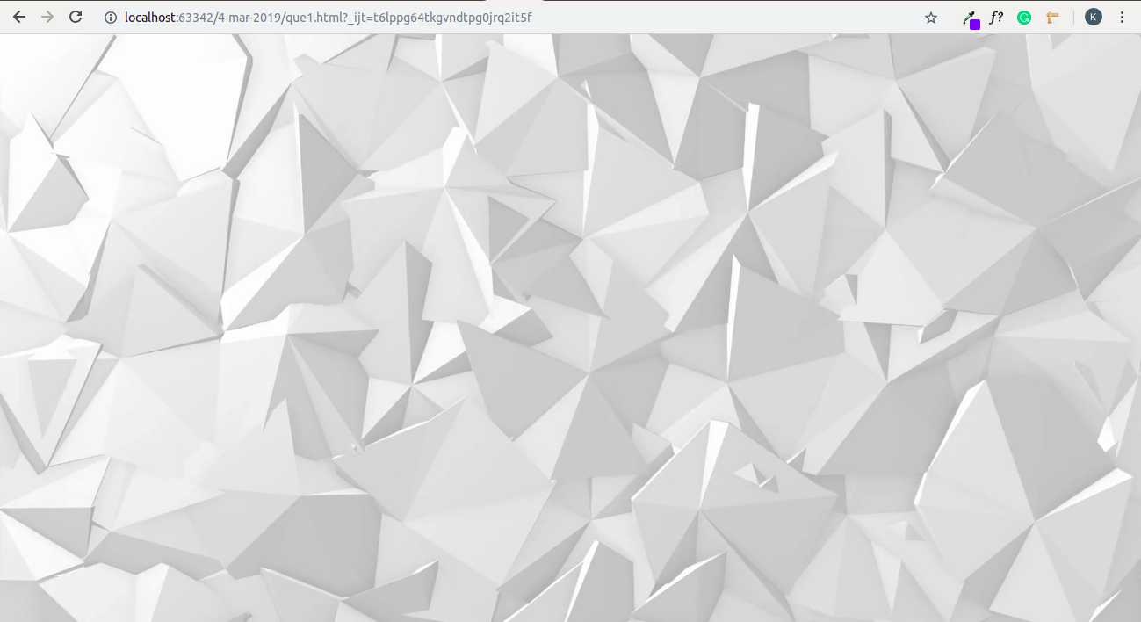

**Que 2: Create a content div(height and width 500px respectively) inside the container Add a background image to the content div which should also be horizontally and vertically centered.**

**Code:**

<!doctype html>

<html lang="en">

<head>

<meta charset="UTF-8">

<meta name="viewport"

content="width=device-width, user-scalable=no, initial-scale=1.0, maximum-scale=1.0, minimum-scale=1.0">

<meta http-equiv="X-UA-Compatible" content="ie=edge">

<title>Document</title>

<style>

*, body{

width: 100%;

height: 100%;

margin: 0;

box-sizing: border-box;

}

.content{

height: 500px;

width: 500px;

background-image: url("assets/content-image.jpeg");

background-repeat: no-repeat;

background-position: center ;

border: 1px solid red;

}

</style>

</head>

<body>

<div class="content">

</div>

</body>

</html>

**Output:**

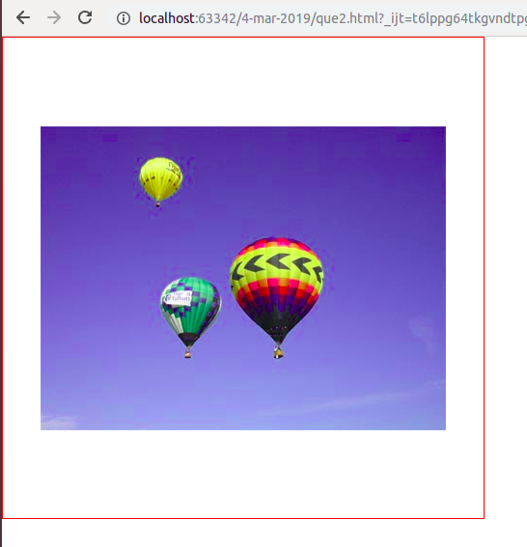

**Que 3: Add p tag inside the content div. The text of the p tag should overflow content height and therefore there must be a scroll on the content div. The background image of the content should scroll with the text.**

**Code:**

<!doctype html>

<html lang="en">

<head>

<meta charset="UTF-8">

<meta name="viewport"

content="width=device-width, user-scalable=no, initial-scale=1.0, maximum-scale=1.0, minimum-scale=1.0">

<meta http-equiv="X-UA-Compatible" content="ie=edge">

<title>Document</title>

<style>

*, body{

width: 100%;

height: 100%;

margin: 0;

box-sizing: border-box;

}

.content{

height: 500px;

width: 500px;

background-image: url("assets/content-image.jpeg");

background-repeat: no-repeat;

background-position: center ;

border: 1px solid red;

overflow-y: auto;

font-weight: bold;

}

</style>

</head>

<body>

<div class="content">

<p>Lorem ipsum dolor sit amet, consectetur adipisicing elit. Accusantium dolorem dolores earum esse facilis impedit incidunt maiores minima modi nesciunt obcaecati omnis quidem quisquam rem saepe, similique ullam veniam voluptate?

Lorem ipsum dolor sit amet, consectetur adipisicing elit. Ab alias aut culpa deleniti, dolores eligendi est explicabo iusto modi molestiae nemo nesciunt, pariatur praesentium quos rem repellendus sunt. Eius, odio.

Lorem ipsum dolor sit amet, consectetur adipisicing elit. Consequatur cupiditate dolorum illum inventore magnam numquam, omnis quaerat, repellat sequi tenetur totam vero? Asperiores autem cumque dolorem excepturi expedita harum itaque!

Lorem ipsum dolor sit amet, consectetur adipisicing elit. Cum delectus deserunt dicta eius explicabo nobis sapiente soluta tenetur voluptate, voluptatibus? Assumenda cumque, dolores modi placeat quis ratione sapiente totam vel.

Lorem ipsum dolor sit amet, consectetur adipisicing elit. A amet aperiam aut consequuntur eaque eligendi eveniet illum impedit itaque, iusto mollitia nemo nesciunt non quae quibusdam quo quod unde ut!

Lorem ipsum dolor sit amet, consectetur adipisicing elit. Aliquam aspernatur cupiditate, deleniti dicta dolore earum eos fuga in iste iusto mollitia neque pariatur quae quasi quibusdam, quisquam repudiandae saepe similique?

Lorem ipsum dolor sit amet, consectetur adipisicing elit. Dicta nesciunt officia quia quisquam quod? Ad deserunt, dicta earum eius est laboriosam laudantium nobis pariatur, praesentium reiciendis repellat, sunt ullam voluptatum!

Lorem ipsum dolor sit amet, consectetur adipisicing elit. Accusamus accusantium, aliquid aut cum eligendi excepturi in iste maxime mollitia necessitatibus nihil, nobis odit officiis quia quod vitae voluptatem. Odio, porro.

Lorem ipsum dolor sit amet, consectetur adipisicing elit. Ab accusantium adipisci cumque eum facere harum inventore libero maxime nihil pariatur perspiciatis quo reprehenderit rerum similique, tempore! Dignissimos eaque quos vitae.

Lorem ipsum dolor sit amet, consectetur adipisicing elit. Corporis libero, magnam placeat quo reiciendis temporibus tenetur? Cumque debitis enim iusto labore libero perferendis quasi voluptate! At earum perspiciatis repellat. Soluta?

Lorem ipsum dolor sit amet, consectetur adipisicing elit. Dolores, saepe, similique? Aperiam, dolore dolorum enim error eum ipsum iure iusto, laborum maiores nobis odit omnis saepe sed, vel voluptates voluptatum.</p>

</div>

</body>

</html>

**Output:**

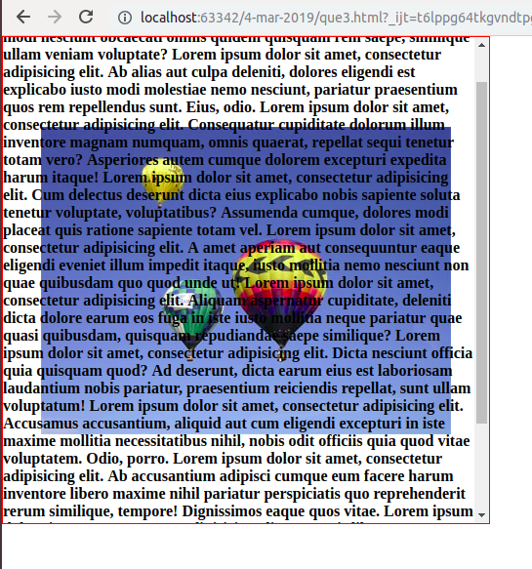

**Que 4: Add background color red to the p tag. The color should be a hex value.**

**Code:**

<!doctype html>

<html lang="en">

<head>

<meta charset="UTF-8">

<meta name="viewport"

content="width=device-width, user-scalable=no, initial-scale=1.0, maximum-scale=1.0, minimum-scale=1.0">

<meta http-equiv="X-UA-Compatible" content="ie=edge">

<title>Document</title>

<style>

*, body{

width: 100%;

height: 100%;

margin: 0;

box-sizing: border-box;

}

.content{

height: 500px;

width: 500px;

background-image: url("assets/content-image.jpeg");

background-repeat: no-repeat;

background-position: center ;

border: 1px solid red;

overflow-y: auto;

font-weight: bold;

}

.content p{

background-color: #f00;

}

</style>

</head>

<body>

<div class="content">

<p>Lorem ipsum dolor sit amet, consectetur adipisicing elit. Accusantium dolorem dolores earum esse facilis impedit incidunt maiores minima modi nesciunt obcaecati omnis quidem quisquam rem saepe, similique ullam veniam voluptate?

Lorem ipsum dolor sit amet, consectetur adipisicing elit. Ab alias aut culpa deleniti, dolores eligendi est explicabo iusto modi molestiae nemo nesciunt, pariatur praesentium quos rem repellendus sunt. Eius, odio.

Lorem ipsum dolor sit amet, consectetur adipisicing elit. Consequatur cupiditate dolorum illum inventore magnam numquam, omnis quaerat, repellat sequi tenetur totam vero? Asperiores autem cumque dolorem excepturi expedita harum itaque!

Lorem ipsum dolor sit amet, consectetur adipisicing elit. Cum delectus deserunt dicta eius explicabo nobis sapiente soluta tenetur voluptate, voluptatibus? Assumenda cumque, dolores modi placeat quis ratione sapiente totam vel.

Lorem ipsum dolor sit amet, consectetur adipisicing elit. A amet aperiam aut consequuntur eaque eligendi eveniet illum impedit itaque, iusto mollitia nemo nesciunt non quae quibusdam quo quod unde ut!

Lorem ipsum dolor sit amet, consectetur adipisicing elit. Aliquam aspernatur cupiditate, deleniti dicta dolore earum eos fuga in iste iusto mollitia neque pariatur quae quasi quibusdam, quisquam repudiandae saepe similique?

Lorem ipsum dolor sit amet, consectetur adipisicing elit. Dicta nesciunt officia quia quisquam quod? Ad deserunt, dicta earum eius est laboriosam laudantium nobis pariatur, praesentium reiciendis repellat, sunt ullam voluptatum!

Lorem ipsum dolor sit amet, consectetur adipisicing elit. Accusamus accusantium, aliquid aut cum eligendi excepturi in iste maxime mollitia necessitatibus nihil, nobis odit officiis quia quod vitae voluptatem. Odio, porro.

Lorem ipsum dolor sit amet, consectetur adipisicing elit. Ab accusantium adipisci cumque eum facere harum inventore libero maxime nihil pariatur perspiciatis quo reprehenderit rerum similique, tempore! Dignissimos eaque quos vitae.

Lorem ipsum dolor sit amet, consectetur adipisicing elit. Corporis libero, magnam placeat quo reiciendis temporibus tenetur? Cumque debitis enim iusto labore libero perferendis quasi voluptate! At earum perspiciatis repellat. Soluta?

Lorem ipsum dolor sit amet, consectetur adipisicing elit. Dolores, saepe, similique? Aperiam, dolore dolorum enim error eum ipsum iure iusto, laborum maiores nobis odit omnis saepe sed, vel voluptates voluptatum.</p>

</div>

</body>

</html>

**Output:**

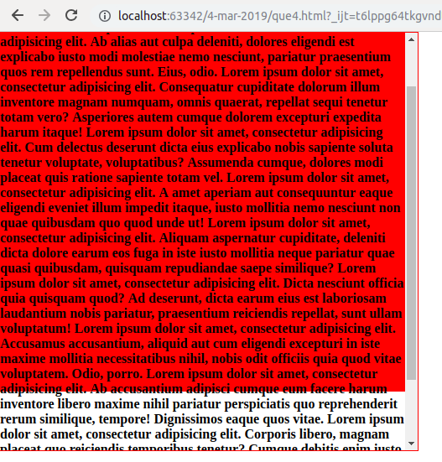

**Que 5: Add a footer to the container div which should contain 3 span tags having background image of facebook , instagram and twitter icons in the same order as written.**

**Code:**

<!doctype html>

<html lang="en">

<head>

<meta charset="UTF-8">

<meta name="viewport"

content="width=device-width, user-scalable=no, initial-scale=1.0, maximum-scale=1.0, minimum-scale=1.0">

<meta http-equiv="X-UA-Compatible" content="ie=edge">

<title>Document</title>

<style>

*, body{

width: 100%;

height: 100%;

margin: 0;

box-sizing: border-box;

}

.container{

width: 100%;

height: 100%;

background-image: url("assets/bg-image.png");

background-size: cover;

background-repeat: no-repeat;

background-attachment: fixed;

}

.container footer{

width: 100%;

height: 100%;

display: flex;

}

span.facebook{

width: 200px;

height: 200px;

background-image: url("assets/footer-image.png");

display: block;

background-position: 20% 0%;

}

span.instagram{

width: 200px;

height: 200px;

background-image: url("assets/footer-image.png");

display: block;

background-position: 0% 0%;

}

span.twitter{

width: 200px;

height: 200px;

background-image: url("assets/footer-image.png");

display: block;

background-position: 40% 0%;

}

</style>

</head>

<body>

<div class="container">

<footer>

<span class="facebook"></span>

<span class="instagram"></span>

<span class="twitter"></span>

</footer>

</div>

</body>

</html>

**Output:**

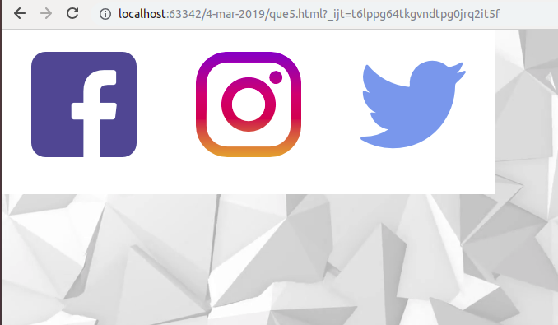

**Que 6 : Create a div with height and width 100px. Animate id twice for total 4 seconds. It should change the opacity of the element from 1 to 0 and then to 0.5. Animation should start after 3 seconds.**

**Code:**

<!doctype html>

<html lang="en">

<head>

<meta charset="UTF-8">

<meta name="viewport"

content="width=device-width, user-scalable=no, initial-scale=1.0, maximum-scale=1.0, minimum-scale=1.0">

<meta http-equiv="X-UA-Compatible" content="ie=edge">

<title>Document</title>

<style>

*, body{

width: 100%;

height: 100%;

margin: 0;

box-sizing: border-box;

}

.container{

width: 200px;

height: 200px;

background-color: #ff0000;

animation-name: animation;

animation-duration: 4s;

animation-delay: 3s;

animation-iteration-count: 2;

}

@keyframes animation {

0% {opacity: 1}

50% {opacity: 0}

100%{opacity: 0.5}

}

</style>

</head>

<body>

<div class="container">

</div>

</body>

</html>

**Output:**

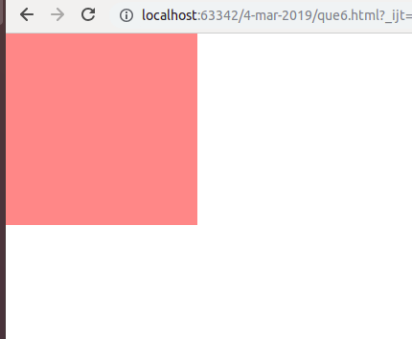

**Que 7. Create a div with height 100px and width 200px respectively. It’s background-color should be #ff00ff with a 1px solid border coloured #000. On active change it’s height to 200px and width to 100px. Background-color should be #000 with a 2px solid border colored #ff00ff. Also scale it to thrice it’s height and twice its width. The whole process should have transition for all the above mentioned properties which should run for 3 seconds.**

**Code:**

<!doctype html>

<html lang="en">

<head>

<meta charset="UTF-8">

<meta name="viewport"

content="width=device-width, user-scalable=no, initial-scale=1.0, maximum-scale=1.0, minimum-scale=1.0">

<meta http-equiv="X-UA-Compatible" content="ie=edge">

<title>Document</title>

<style>

*, body{

width: 100%;

height: 100%;

margin: 0;

box-sizing: border-box;

}

.container{

width: 200px;

height: 100px;

background-color: #ff00ff;

border: 1px solid #000;

cursor: pointer;

}

.container:active{

height: 200px;

width: 100px;

background-color: #000;

border: 2px solid #ff00ff;

transform: scale(3,2);

transition: width 3s,height 3s,background-color 3s,border 3s, transform 3s;

}

</style>

</head>

<body>

<div class="container">

</div>

</body>

</html>

**Output:**

